**JECRC – 45 Days In-campus Training (4 Semester)**

**Subject – Cloud, Devops & SRE**

**Topic – AWS, DOCKER**

**MINI PROJECT 3**

**Title:** Containerizing a GUI Application (VS Code)

**Introduction:**

In this mini-project, we will explore the process of pulling a VS Code docker image and then running it on the local browser. In short, we are containerizing that VS Code image and then we are just running it on the browser.

**Objective:**

The main objective of this mini-project is to demonstrate how to containerize a GUI Application (here it is VS Code) and running it on the localhost’s browser.

**Tools and Technologies:**

Amazon Web Services (AWS) account

Amazon Elastic Compute Cloud (EC2)

Docker

Docker Hub Image of VS Code

**PROCEDURE:**

1. First, we have to create a EC2 instance and then find the proper docker image of VS Code.

Here, I already have an image of VS Code with me (aakashgaur57/code).

Use this image or any other image that you find suitable/appropriate.

1. Now, we can easily pull the image and then containerize it but we have to first assign it to a port (2244:8080) and also we have to add password to it so that not everybody can use this.

For port we’ll use -p 2244:8080

For password we’ll use -e PASSWORD=q123

So, overall command will look like this:

**-> docker run -d -e PASSWORD=q123 -p 2244:8080 aakashgaur57/code**

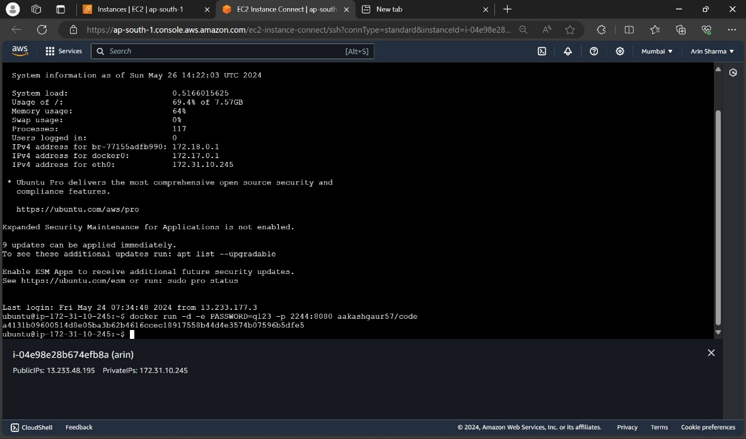

1. After running the above command, enter your ip with the port number in your local browser.

Then, a window will pop up that will ask for the password so, enter the password and your VS Code webapp will be live and ready to use and will look like this.

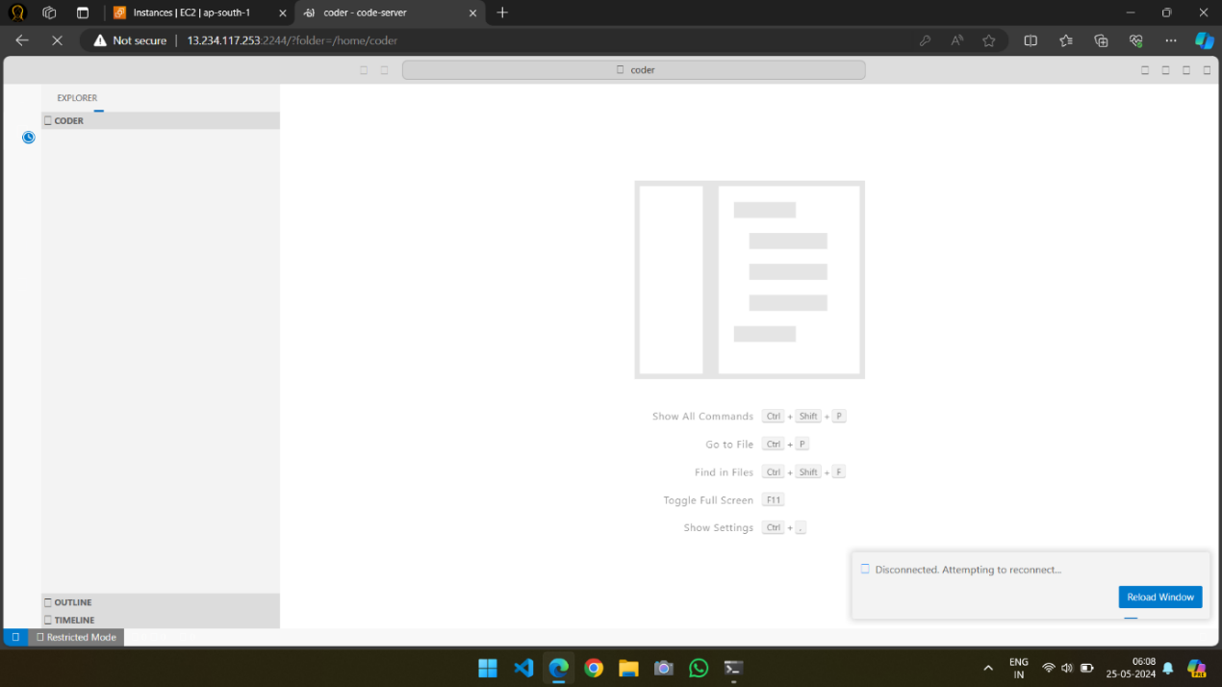

**CONCLUSION:**

In the end, we were able to containerize a GUI Application (VS Code) with setting its port number and environment variable.